Contact: Martha Hill, Northeast Kingdom Youth Services
802-748-8732 or martha@nekys.org

FOR IMMEDIATE RELEASE

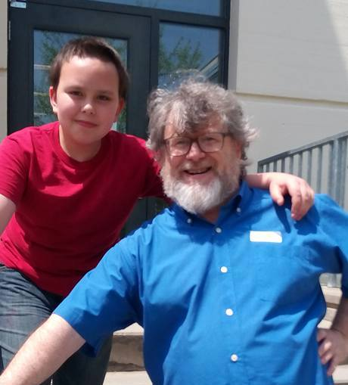
Wes Robertson and his current mentee, Dylan.

Connie Sandahl, director of Northeast Kingdom Youth Services (NEKYS), is pleased to announce that Wes Robertson has become the new head of NEKYS’s JUMP Mentoring Program. Wes is a long time mentor and brings to this new role a deep understanding of how this program impacts kids. According to Wes, “The JUMP program can really change the lives of youth in meaningful ways. I am delighted to head this great program and look forward to working with the mentors, kids, and schools.”

JUMP Mentoring matches trained adult mentors with youth in grades one through eight. In this
school-based program, mentors commit to one hour a week for the academic year. Mentors and mentees spend time together talking, eating lunch, playing games, doing arts and crafts, riding bicycles and playing soccer, or simply hanging out.

If this sounds interesting to you, we are looking for new mentors for this coming school year. You can stop by NEKYS at 24 Bagley Street, St. Johnsbury, or call 802-748-8732 or e-mail wes@nekys.org. We are changing lives one relationship at a time!

#####

